

Column Drop CSS

Alumno | Carlos Daniel Garfio Murillo
Matricula | 1117150109
Materia | Desarrollo De Aplicaciones Web
Maestro | M.G.T.I. Blanca Estela Chavarria Salinas
Fecha | 9 de noviembre de 2021
Grupo | ITI91N

Index.html
<!DOCTYPE html>
<html lang="en">
<head>
<meta charset="UTF-8" />
<meta http-equiv="X-UA-Compatible" content="IE=edge" />
<meta name="viewport" content="width=device-width, initial-scale=1.0" />
<title>Ejercico 7</title>

<link rel="stylesheet" href="./css/estilos.css" />
</head>
<body>
<div class="contenedor column-drop-css">
<main>
<h1>Column Drop Css Grid (Primera Columna)</h1>
<p>
Lorem ipsum dolor sit amet, consectetur adipisicing elit. At id
voluptas eaque. Corporis doloremque sunt distinctio perspiciatis
maxime error, quas inventore? Dolor natus obcaecati laboriosam
pariatur, repellendus sequi ea magnam.
</p>
</main>
<aside class="primera">
<h1>Titulo Imagen (Segunda Columna)</h1>
<p>
Lorem ipsum dolor sit amet consectetur adipisicing elit. In,
distinctio alias beatae recusandae debitis ducimus dolor eius
laudantium officiis necessitatibus quos dicta eveniet eligendi libero,
commodi quam sint aliquid ratione.
</p>
</aside>
<aside class="segunda">
<h1>Titulo Imagen (Tercera Columna)</h1>
<p>
Lorem ipsum dolor sit amet consectetur adipisicing elit. In,
distinctio alias beatae recusandae debitis ducimus dolor eius
laudantium officiis necessitatibus quos dicta eveniet eligendi libero,
commodi quam sint aliquid ratione.
</p>
</aside>
</div>
</body>
</html>

CSS
@import url("https://fonts.googleapis.com/css2?family=Poppins:wght@400;700&display=swap");

*,
*::before,
*::after {
box-sizing: border-box;
margin: 0;
padding: 0;
}

body {
font-family: Poppins, sans-serif;
font-weight: 500;
}

img {
max-width: 100%;
}

h1 {
font-size: 4rem;
}

.contenedor {
max-width: 1200px;
width: 95%;
margin: 0 auto;
}

.column-drop-css {
display: grid;
gap: 2rem;
}

/* Extra small devices (phones, 600px and down) */
@media only screen and (max-width: 600px) {
.column-drop-css: {
grid-template-columns: repeat(2, 1fr);
}

.primera {
grid-column: 1/3;
grid-row: 2/3;
}

.segunda {
grid-column: 2/3;
grid-row: 1/3;
}
}

/* Small devices (portrait tablets and large phones, 600px and up) */
@media only screen and (min-width: 600px) {
}

/* Medium devices (landscape tablets, 768px and up) */
@media only screen and (min-width: 768px) {
.column-drop-css: {
grid-template-columns: repeat(3, 1fr);
}

.primera {
grid-column: 2/3;
grid-row: unset;
}

.segunda {
grid-column: 3/4;
grid-row: unset;
}
}

/* Large devices (laptops/desktops, 992px and up) */
@media only screen and (min-width: 992px) {
}

/* Extra large devices (large laptops and desktops, 1200px and up) */
@media only screen and (min-width: 1200px) {
}

Resultados
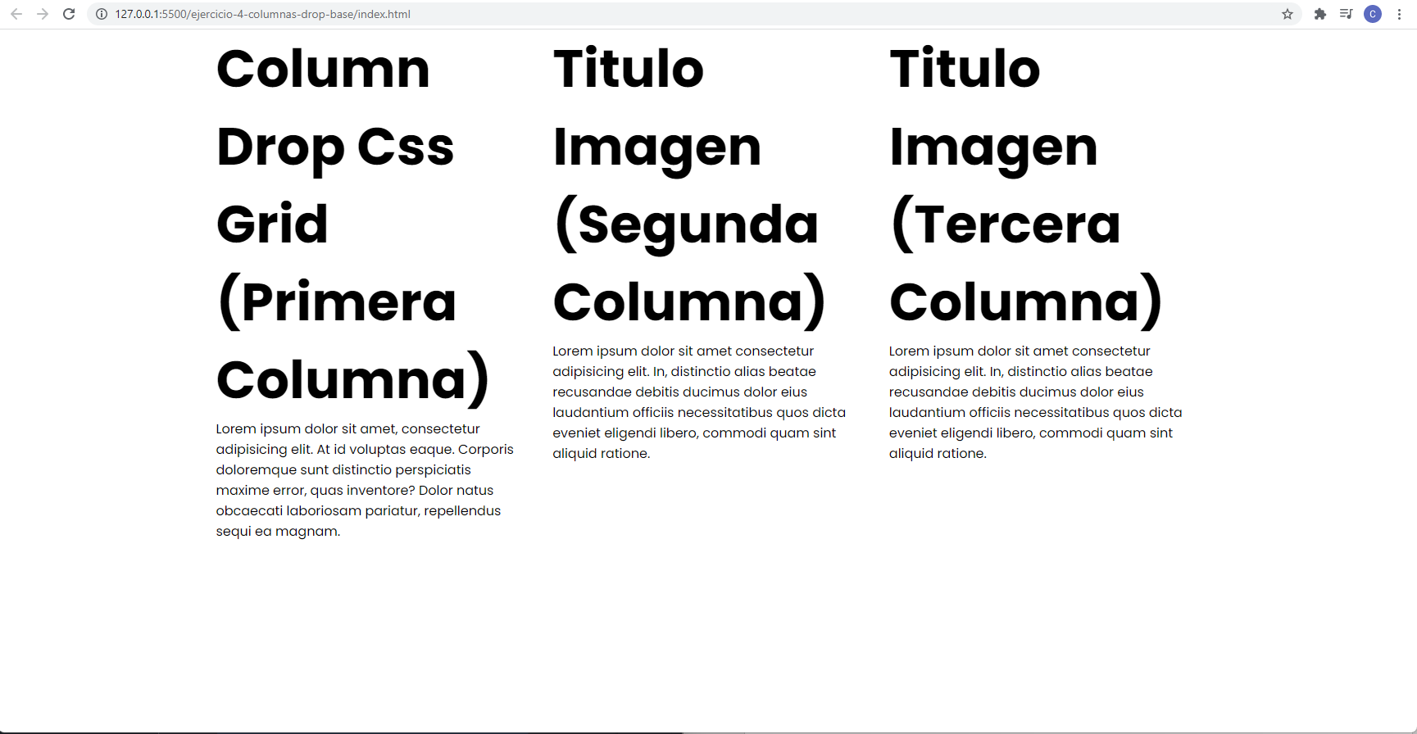
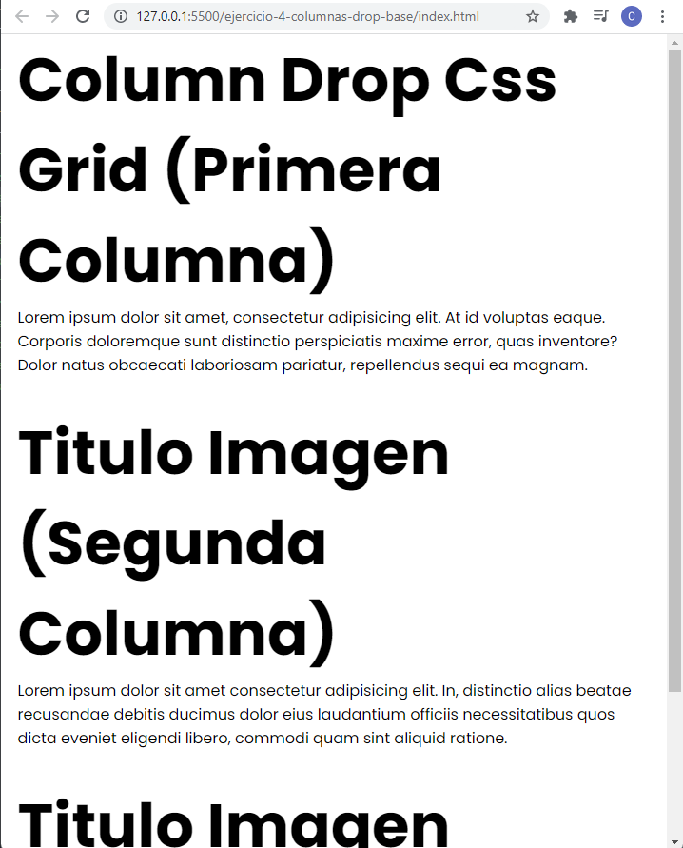
Codigo Fuente
https://github.com/CarlosGarfio/Desarrollo-de-Aplicaciones-Web

